PROJECT PROPOSAL

Library Management System
A Web-Based Application

Prepared By | Tafsir Khan
Department | Information and Communication Technology (ICT)
Institution | Mawlana Bhashani Science and Technology University (MBSTU)
Technology Stack | Spring Boot, React.js, HTML5, CSS3, MySQL

1. Introduction
A library plays an important role in educational institutions by providing students and faculty members with access to books and other learning resources. Managing books, recording lending and return transactions, maintaining student information, and tracking book availability manually can be time-consuming and prone to errors.
The proposed Library Management System (LMS) is a web-based application designed to simplify and automate these activities. An authorized librarian will be able to register books, maintain book records, manage student information, issue books to students, and record returned books. When a book is issued, the system will store the student's name, student ID, educational email address, and phone number, together with the book and transaction details.
The backend will be developed using Spring Boot, while React.js, HTML5, and CSS3 will be used to build an interactive frontend. MySQL will store and manage application data.

2. Problem Statement
Traditional library management often relies on handwritten registers or spreadsheets. These methods can make it difficult to track available and borrowed books, maintain accurate student and transaction records, identify who has borrowed a particular book, and produce reliable reports. A computerized system is needed to improve accuracy, efficiency, and organization.

3. Objectives
- Maintain a centralized database of library books.
- Allow the librarian to register new books and update existing records.
- Manage book issuing and returning operations.
- Record student name, student ID, educational email, and phone number.
- Track the current availability of each book.
- Maintain borrowing and return histories.
- Provide search and filtering for books, students, and transactions.
- Implement secure authentication and role-based access for authorized users.
- Reduce manual paperwork and record-keeping errors.

4. Proposed System
The librarian will log in and access a dashboard showing key information such as total book copies, available copies, issued books, and active borrowing transactions. When a book is added, the system will store its title, author, ISBN, category, publisher, and quantity. When a student borrows a book, the librarian will select the student and book, record the issue and due dates, and the system will update availability. On return, the librarian will record the return date, close the transaction, and restore the available quantity.

5. Main Features and Functionalities

5.1 Authentication and Authorization
- Secure librarian login and logout.
- Protected management pages and operations.
- Access control for authorized users.

5.2 Book Management
- Register, update, and deactivate or remove book records when appropriate.
- Store title, author, ISBN, category, publisher, total quantity, and available quantity.
- Search books by title, author, ISBN, or category.
- View available, issued, and total copies.

5.3 Student Information Management
- Register or record student information.
- Store student name, institutional student ID, educational email, and phone number.
- Search students by name or student ID.
- View each student's current borrowed books and borrowing history.

5.4 Book Issuing
- Select a student and a book.
- Record issue date and expected return date.
- Record the librarian responsible for the transaction.
- Prevent issuing when no copies are available.
- Update book availability automatically.

5.5 Book Return Management
- Find an active borrowing transaction.
- Record the actual return date and mark the transaction as returned.
- Restore available book quantity.
- Maintain completed transaction history.

5.6 Dashboard and Reports
- Display total books and total copies.
- Show available copies and currently issued copies.
- Display active borrowing transactions and overdue books.
- Generate reports of issued and returned books.

6. Technology Stack
Technology | Purpose
Java | Backend programming language
Spring Boot | Backend application and REST APIs
Spring Data JPA / Hibernate | Database access and object-relational mapping
Spring Security | Authentication and authorization
React.js | Interactive frontend
HTML5 and CSS3 | Web page structure, styling, and responsive layouts
MySQL | Relational database
Maven | Backend dependency management and build
Git and GitHub | Version control and collaboration
Postman | REST API testing

7. System Architecture
The application will follow a three-layer architecture:
- Presentation Layer — React.js: Provides the librarian interface, including dashboards, forms, book tables, student records, and issue/return pages.
- Application Layer — Spring Boot: Provides REST APIs, validates requests, applies library business rules, manages transactions, and enforces access control.
- Data Layer — MySQL: Stores book records, student information, librarian accounts, and borrowing transactions.
The frontend will communicate with the backend through HTTP requests using JSON.

8. Database Design
Books
- book_id (PK), title, author, isbn, category, publisher, total_quantity, available_quantity
Students
- student_id (PK), student_name, student_number (unique), educational_email, phone_number
Librarians
- librarian_id (PK), name, username, password_hash, role
Borrowing Transactions
- transaction_id (PK), book_id (FK), student_id (FK), librarian_id (FK), issue_date, due_date, return_date, status
Each borrowing transaction will represent one book copy issued to one student. Foreign keys will link each transaction to its book, student, and responsible librarian. The system will prevent negative availability and will not allow the same transaction to be returned more than once.

9. Development Methodology
- Requirement Analysis: Identify functional and non-functional requirements.
- System Design: Design the database schema, architecture, and user interface.
- Backend Development: Implement entities, repositories, services, controllers, and REST APIs.
- Frontend Development: Build React components, forms, tables, navigation, and dashboards.
- Integration: Connect the React frontend to the Spring Boot backend.
- Testing: Test authentication, registration, issuing, returning, validation, and database operations.
- Deployment and Documentation: Prepare deployment instructions, user documentation, and the final report.

10. Expected Outcomes
- A functional web-based library management application.
- Faster and more accurate book registration and inventory tracking.
- Organized student and borrowing records.
- Reliable book issuing and returning workflows.
- Better visibility into book availability and overdue transactions.
- A maintainable application built with modern Java web technologies.

11. Scope and Future Enhancements
The initial version will focus on librarian-operated library management. Future enhancements may include:
- Student login and personal borrowing history.
- Automated overdue reminders through email.
- Fine calculation for late returns.
- Barcode or QR-code-based book identification.
- Book reservation and waiting lists.
- Exportable PDF or Excel reports.
- Multiple librarian accounts and administrative roles.
- Analytics for popular books and borrowing trends.

12. Project Timeline and Gantt Chart
The following proposed schedule spans eight weeks. The exact duration can be adjusted based on team size, course requirements, and available time.
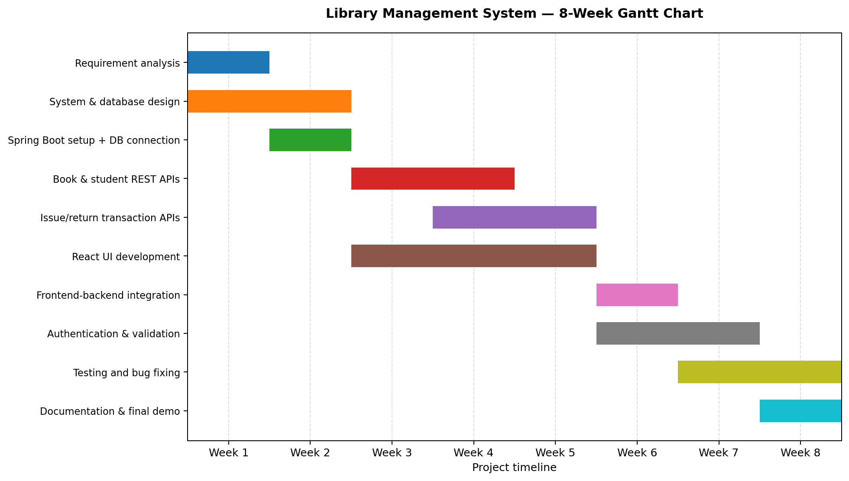
Task | Start Week | End Week
Requirement analysis | 1 | 1
System and database design | 1 | 2
Spring Boot setup and database connection | 2 | 2
Book and student REST APIs | 3 | 4
Issue/return transaction APIs | 4 | 5
React UI development | 3 | 5
Frontend-backend integration | 6 | 6
Authentication and validation | 6 | 7
Testing and bug fixing | 7 | 8
Documentation and final demo | 8 | 8

13. Conclusion
The proposed Library Management System aims to modernize library operations by replacing manual record-keeping with a centralized web application. By combining Spring Boot, React.js, and MySQL, the system will provide a practical solution for managing books, student information, and borrowing transactions. The project will also provide practical experience with object-oriented programming, database management, REST API development, frontend development, authentication, and software engineering.

